Ex. No. : 5

Date:

**SELECT with various clause – BETWEEN, IN, Aggregate function**

1. The instructor wants to know the CourseNos whose scores are in the range 50

to 80

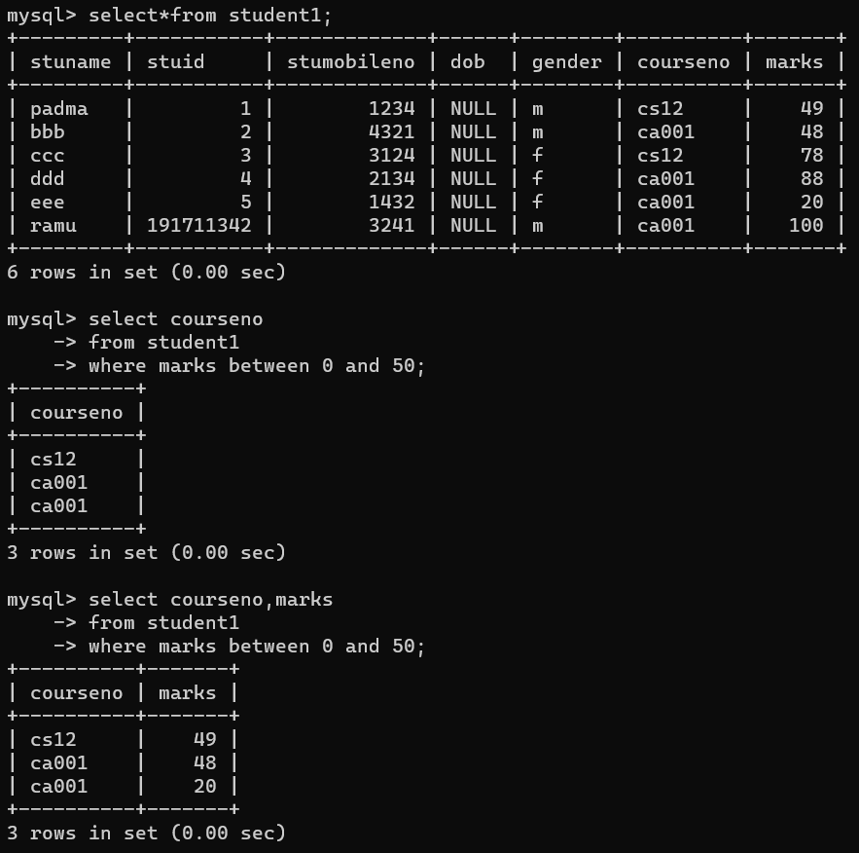

1. Find the average mark of “C002”.

